FORM B − BUILDING

Massachusetts Historical Commission
Massachusetts Archives Building
220 Morrissey Boulevard
Boston, Massachusetts 02125

Photograph
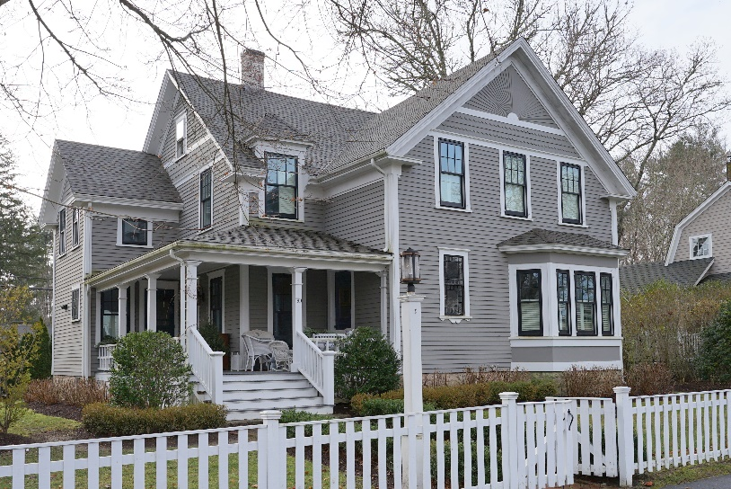

Locus Map

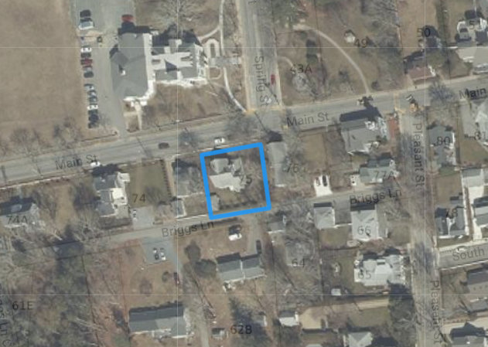
Aerial Imagery, 2021

Recorded by: Eric Dray, Preservation Consultant
Organization: Sippican Historical Society
Date (month / year): February 2023

Assessor’s Number USGS Quad Area(s) Form Number

15 75 |  | Marion |  | N, AA |  | MRN.258

Town/City: MARION
Place: (neighborhood or village): Marion Village -
Main Street (MRN.AA)
Address: 70 Main Street
Historic Name: William Handy House
Uses: Present: Single Family Dwelling House
Original: Single Family Dwelling House
Date of Construction: ca. 1885
Source: Historic maps, building form/details
Style/Form: Queen Anne
Architect/Builder: Unknown
Exterior Material:
Foundation: Rough-cut granite/stone
Wall/Trim: Wood clapboard/ Wood
Roof: Asphalt shingles
Outbuildings/Secondary Structures:
Shed with low hip roof (Photo 3, pre-1933)
Major Alterations (with dates)*:
None on record

*Based on Property Card and/or observation
Condition: Good
Moved: no yes Date:
Acreage: 0.20 acres
Setting: The surrounding area includes mostly 19th and early-20th century houses sited relatively close to the street and to each other along Main Street. The immediate surroundings also include the former Tabor Academy across the street. This house is also set relatively close to the street on its level parcel. The front yard is enclosed by a wood picket fence, and the front yard is landscaped with lawn and foundation plantings. A brick walkway leads to the front entrance. This parcel backs up to Briggs Lane where there is an asphalt parking area and a low hip-roofed outbuilding.

Recommended for listing in the National Register of Historic Places.
If checked, you must attach a completed National Register Criteria Statement form.

Use as much space as necessary to complete the following entries, allowing text to flow onto additional continuation sheets.

ARCHITECTURAL DESCRIPTION:
Describe architectural features. Evaluate the characteristics of this building in terms of other buildings within the community.

This house could be classified as a charming example of the Queen Anne style. The Queen Anne style, popular from ca. 1880-1910, employed different roof shapes and surface materials to enliven a building’s elevations and create a more “picturesque” effect than earlier, more formal styles. This building has an unusual form. Typically, there is a gable-front main block with stepped down lateral ells. In this case, however, it is the opposite. The gable-front “main” block is stepped down from the side-gable block behind it. This side-gable block extends beyond the elevation of the gable-front block on the left (east) side, and terminates in a tall, gabled wall dormer on the right (west) side elevation. The left ell has a stepped-down extension. The roof form is further animated by a tall, single-window wall dormer with hip roof on the main roof in front of the left side ell, and there is a broad, hexagonal bay on the front elevation.

The building rests, like most 19th century houses in Marion Village, on a raised rough-cut granite foundation. The elevations are clad, primarily, in wood clapboards. However, the elevations are further animated by beltcourses above the second story windows. In addition, the gable peak of the front elevation is clad in boards to simulate a sunburst pattern, with scalloped shingles below (Queen Anne details). This elegant detail is replicated in the gable peak of the right (west) elevation. Fenestration on the house consists primarily of modern, replacement 6/1 windows. That may have been the original muntin pattern. Another Queen Anne detail is the double-height window lighting the interior stairwell that consists of two stacked “Queen Anne” windows – windows with small square panes around a large central pane. This feature is further ornamented with a curvilinear skirt below the sill. Another unusual window is the diamond-shaped sash in the gable peak of the right wall dormer.

An open porch fills in the space between the front elevation and the left (east) ell. This porch is supported by square columns, and the porch is enclosed by an unusual, square-design balustrade. There are two entrances accessed from the front porch that wraps around the left side elevation. Both entrances appear to have paneled doors set in simple surrounds.

HISTORICAL NARRATIVE
Discuss the history of the building. Explain its associations with local (or state) history. Include uses of the building, and the role(s) the owners/occupants played within the community.

The dense development pattern along Main Street, starting in the eary-19th century with increasing maritime-related prosperity, extended only as far west as Pleasant Street. Although Upper Main Street (as it is locally called), was set out in 1829, residential development was limited to a few houses on large parcels. The building of the Public Library in 1872 and Tabor Academy in 1876 along Spring Street may have inspired increased residential development in the surrounding area. By the late-19th century, owners of the larger tracts of land on upper Main Street began to build additional houses on their land and/or sell off portions to others.

The south side of Main Street, across from the former Tabor Academy campus, was a single parcel up until the early-20th century. In 1842, Paddock Bates sold that parcel, without buildings, to Nathan Savery. Nathan Savery (1774-1858) was a carpenter. The first house he built was 76 Main Street (MRN.260). It was the first of four that would be built along this parcel. Since Savery was a carpenter, there is a good chance it was built by him. By the 1855 State Census, Savery was living there at the age of 82 with his daughter Patience (1803-1885), her husband Benjamin Chamberlain (1803-1874), a blacksmith, and their three children. That house was inherited by Patience and Benjamin Chamberlain, and they were living in Carver in 1866 when they sold it to William Handy.
76 Main Street, still the only house, is shown on the 1879 Plymouth County Atlas with the name “Wm. Handy” (Figure 2). William Handy (1831-1904) was listed as a mariner and sea captain in census records and, by 1900, was retired. He was living at 76 Main Street with his second wife, Ellen (Downing), whom he married in 1890, and two of their children. Ellen Handy (1853-1902) was 22 years younger than William Handy, and it was her second marriage as well.

William Handy developed two more houses as rental properties east of his own house – this house and 72 Main Street (MRN.259). Both are shown with the Handy name on the 1903 Plymouth County Atlas (Figure 3). It is unclear when this house was built. It has an Assessor date of 1885, and the gable-front form and other features likely indicate a late-19th century construction, which means it was very likely built by Handy before he built the smaller house next door at 72 Main Street. In ca. 1904, Handy built a fourth house, what is now 90 Main Street (MRN.262).

In 1916, three of William Handy’s children (from different marriages) – Leon C. Handy of Boston, Josephine Glidden of Falmouth, and Harry Handy of Scituate – sold this house to Bessie Clark Nelson of Marion. She was a direct descendant of Noble Bates (1791-1864), one of the Two Captains who lived at 2 Main Street (MRN.220). Bessie Clark Blankinship (1879-1946) had married Sweden-born James Nelson in Marion in 1900. They had immediately rented this house from the Handys, which they were able to buy 16 years later. They also bought the house next door, 72 Main Street John (ca. 1900, MRN.259). James Nelson (1872-1951) worked as a barber. They had no children, but Bessie’s sister, Lucy Blankinship, lived with them for many years. The property was sold out if the family following James Nelson’s death.

It was sold to Ferman and Dorothy Davis who, in 1965, sold it to their son and daughter-in-law, Charles R. and Lucia Davis. The house stayed in the extended Davis family until 2013. Charles R. Davis (d. 2016) was a local painting contractor and served on the Marion Fire Department for over 50 years, retiring as chief in 2002.

BIBLIOGRAPHY and/or REFERENCES
Maps and Atlases:
1855, Walling, H. F. Map of the Town of Marion, Plymouth County, Massachusetts, 1855.
1879, Atlas of Plymouth County, Massachusetts. Boston: Geo. H Walker & Co, 1879.
1903, Atlas of Surveys of Plymouth County. Springfield, MA: L. J. Richards Co., 1903.
Ancestry.com – Vital records.
Dempsey, Claire. MHC Area Form AA, Main Street, 2021.
Gordon, Edward. MHC Area Form N, Wharf Village, 1998.
Plymouth County Registry of Deeds
Sippican Historical Society Collections.
www.chapmanfuneral.com/obituaries/Charles-R-Davis?obId=20630817.

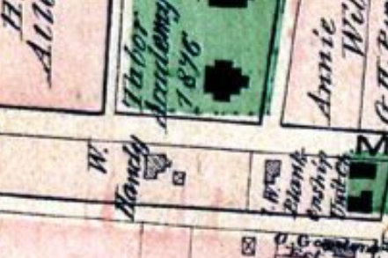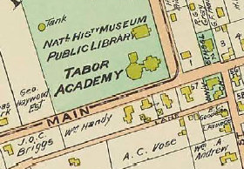
Figure 2. Detail of 1879 Plymouth County Atlas (arrow added Figure 3. Detail of 1903 Plymouth County Atlas (arrow added
to location of future 70 Main Street). to 70 Main Street).

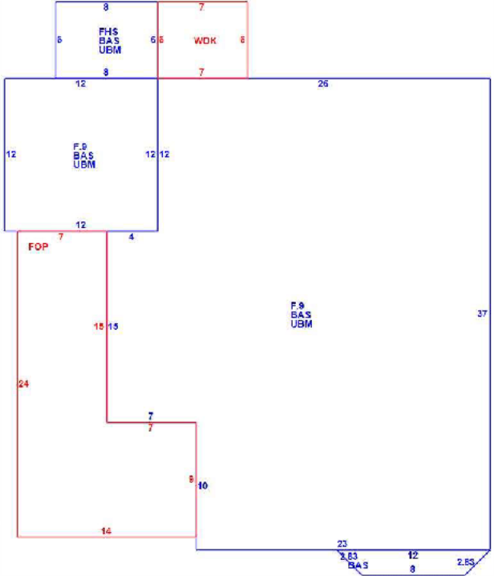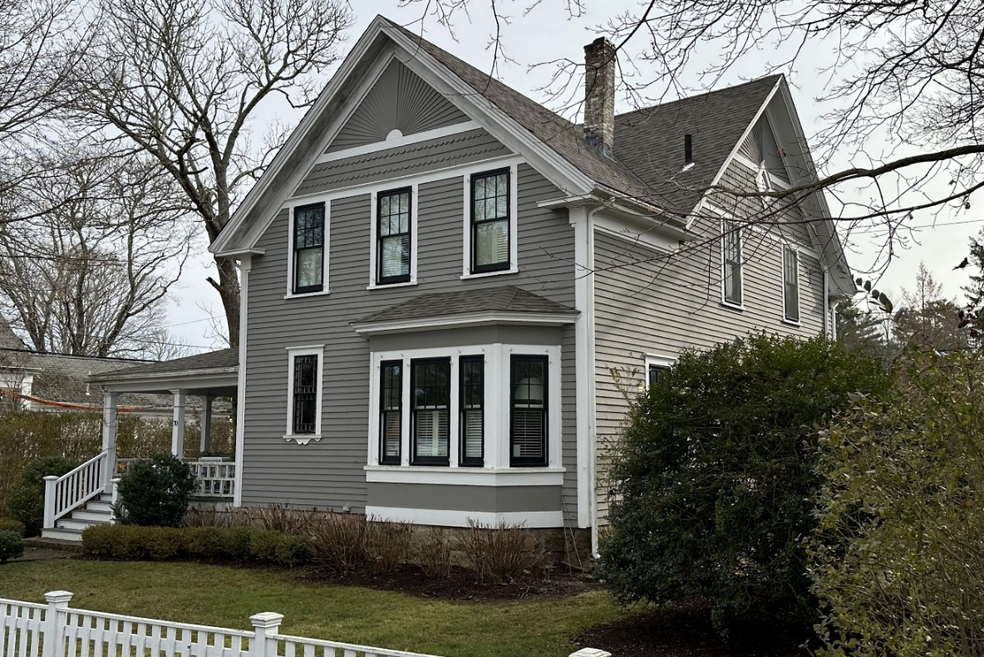
Figure 1. Marion Assessor Sketch. Photo 2. View from Main Street, looking southeast.

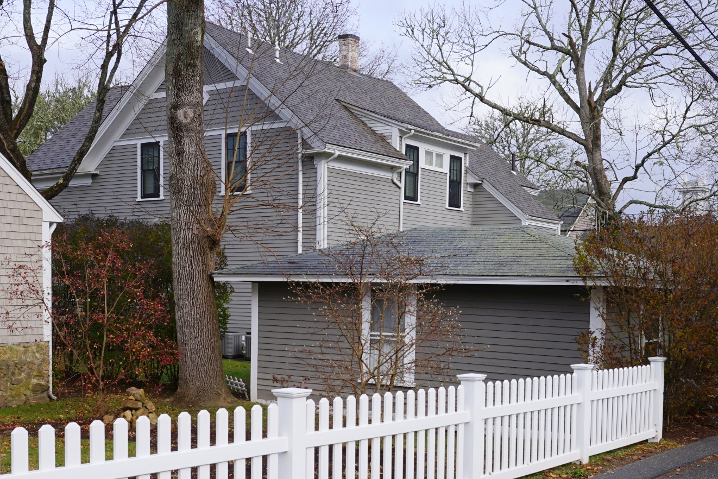
Photo 3. View of outbuilding and rear elevation of house, looking northeast from Briggs Lane.

National Register of Historic Places Criteria Statement Form

Check all that apply:

Individually eligible Eligible only in a historic district

Contributing to a potential historic district Potential historic district

Criteria: A B C D

Criteria Considerations: A B C D E F G

Statement of Significance by__Eric Dray, Preservation Consultant for Sippican Historical Society
The criteria that are checked in the above sections must be justified here.

This property is a contributing resource in the combined Areas of Wharf Village-Sippican Village (MRN.N) and Water Street (MRN.L), hereinafter referred to as Marion Village.*

Marion Village is recommended as eligible for listing at the local level under Criterion A in the area of Maritime History. Marion Village contains the great majority of buildings connected to Marion’s historical maritime development beginning in the late-18th century. With the rise of saltmaking, shipyards, and whaling, maritime activity increased dramatically into the mid-19th century, as did residential development in Marion Village. In addition to the houses built by those in the maritime industry, Marion Village contains numerous buildings and structures associated with maritime industrial activity, including a chandlery, sail loft, cooperage, and wharves. As Marion Village’s prosperity became linked to Sippican Harbor, Marion Village also became the commercial, political and institutional center of the town.

Marion Village is also recommended as eligible for listing at the local level under Criterion A in the area of Entertainment/ Recreation. Starting in the mid-19th century, maritime activity declined significantly. The decline in maritime activity was eventually replaced by the rise in the 1870s of a summer colony as Marion Village emerged as an elite summer resort. This was facilitated by the arrival of train service in the 1854. Summer visitors, including artists and writers, were drawn Sippican Harbor’s beauty and tranquility. A large hotel, the Sippican Hotel, was located at the corner of South and Water Streets, and a few houses were converted to inns. While the hotel was town down in 1929, a large livery complex built by the Hiller Brothers at 147 Front Street (MRN.216) is extant. They provided horse-drawn vehicles to summer visitors registered at the Sippican Hotel, and ferried guests back and forth between the hotel and the train depot. In Marion Village, ownership (or occupancy through rental) of many houses began to shift from local maritime families to seasonal residents, including nationally-noteworthy politicians, businessmen, artists and writers. During this period, Marion Village also saw the addition of high style, architect-designed summer cottages and recreation resources.

Marion Village is recommended as eligible for listing at the local level under Criterion C in the area of Architecture. Marion Village is a remarkably intact historic town center, including a compact collection of historic dwellings, along with a few churches, schools, commercial buildings and recreation buildings. Marion Village contains a great concentration of Federal and Greek Revival houses; and examples of later Victorian-era styles, including high-style examples of summer house architecture along Sippican Harbor and large institutional buildings not found elsewhere in Marion.

The great majority of resources in Marion Village retain substantial integrity of location, setting, materials, workmanship, design, feeling, and association.

*The potential Marion Village district boundaries include surveyed areas within the boundary of MRN.N completed in 2020-2022 for Barden-Hiller (MRN.Y), Cottage Street (MRN.Z), Main Street (MRN.AA), South Street (MRN.AB), Upper Pleasant Street (MRN.AC), and Upper Main Street (MRN.AH).

Plymouth County Registry of Deeds, Book 206/ Page 217.
PCRD, Book 339/ Page 217.
PCRD, Book 1257/ Page 1.
PCRD, Book 2236/ Page 199.
PCRD, Book 3260/ Page 145.

